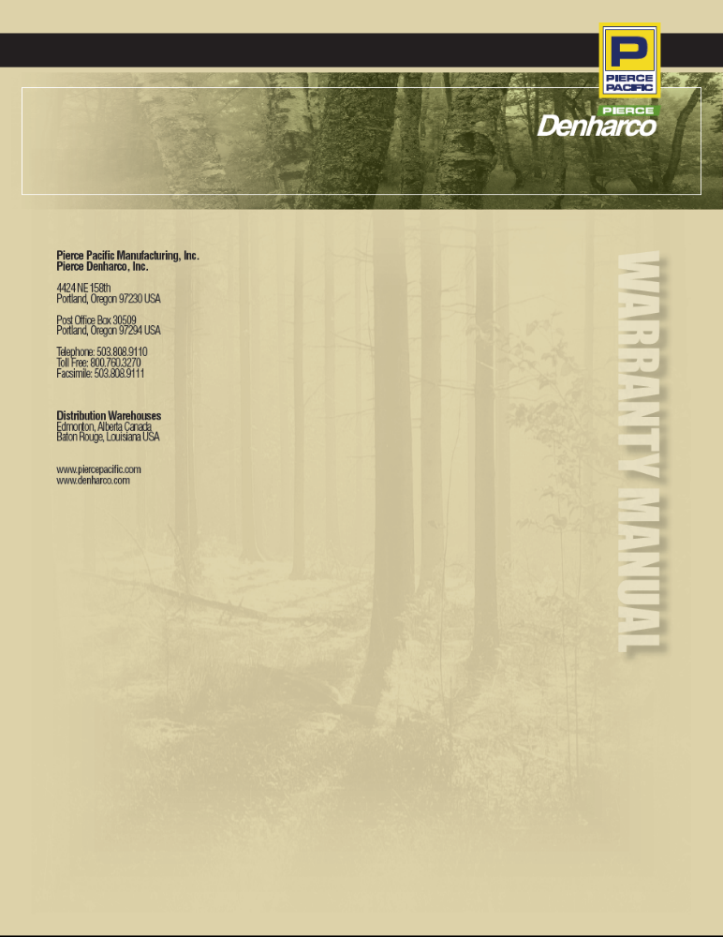

TABLE OF CONTENTS:

1.1.0 | INTRODUCTION | 4
2.0.0 | WARRANTY | 5
2.1.0 | STANDARD WHOLEGOOD WARRANTY | 5
2.1.1 | ADJUSTMENTS WITHIN THE WARRANTY PERIOD | 6
 | REIMBURSEMENT OF PARTS | 6
 | RETURN OF FAILED PARTS | 6
 | RETURN OF DEFECTIVE NEW PARTS | 6
 | SPECIAL FABRICATIONS: RETURNS | 6
 | MATERIAL SHIPPED IN ERROR | 6
2.1.2 | EXTENDED WARRANTIES | 6
2.1.3 | EXCLUSIONS | 6
 | WEAR ITEMS & CONSUMABLES | 6
 | ADDITIONAL EXCLUSIONS | 7
 | TRAVEL TIME | 7
 | MILEAGE | 7
 | FREIGHT | 7
 | MAJOR REPAIRS & SUBCONTRACTORS | 7
2.2.0 | REPLACEMENT PARTS WARRANTY | 7
 | WHOLEGOOD AND REPLACEMENT PARTS DISCLAIMER | 8
3.0.0 | WARRANTY VALIDATION | 9
3.1.0 | SCALE OF DISTRIBUTOR REFUNDS | 9
 | PARTS | 9
 | LABOR | 9
3.2.0 | REVIEW OF DECISION | 9
3.3.0 | WARRANTY POLICY: PRODUCTS IN STOCK | 9
3.4.0 | WARRANTY POLICY: PRODUCTS ON DEMONSTRATION/RENTAL AGREEMENT | 9
4.0.0 | WARRANTY CLAIMS | 11
4.1.0 | WARRANTY CLAIMS PROCEDURES | 11
 | A) COMPLETE THE FORM | 11
 | B) SEND THE FORM | 11
 | RETURN OF PARTS, AS REQUESTED | 11
 | ISSUIING A CREDIT ON THE CLAIM | 11
 | DISCARDING OF MATERIAL IN DEALER/CUSTOMER'S FACILITY | 12
4.2.0 | RETURNING CLAIMED/DEFECTIVE PARTS | 12
4.3.0 | FIELD CAMPAIGN PROCEDURES | 12
 | NOTIFICATION OF CAMPAIGN | 12
 | DESCRIPTION OF CHANGE | 12
 | ORDERING CAMPAIGN MATERIAL | 12
 | REPLACEMENT PROCEDURE | 12
 | SPECIAL INSTRUCTIONS | 12
 | DISPOSITION OF REPLACED PARTS | 12
 | REIMBURSEMENT VIA APPLICATION FOR ADJUSTMENTS | 12
 | SERVICE ASSISTANCE & REPAIRS | 13
5.0.0 | SERVICE PUBLICATIONS | 14
 | GENERAL POLICY, NEW WHOLEGOOD PRODUCTS | 14
 | SERVICE LITERATURE PROCUREMENT/CHARGES | 14
 | SERVICE LITERATURE, USED MACHINES | 14
6.0.0 | DEALER'S RESPONSIBILITIES | 15
6.1.0 | CUSTOMER'S RESPONSIBILITIES | 15
APPENDIX 1 | EXTENDED WARRANTY POLICY | 16
 | DELIMBER BOOMS | 16
 | DELIMBER DRIVE CHAINS | 16
 | DELIMBER DRIVE MOTORS | 16
APPENDIX 2 | COMPUTERS | 18
 | NEW & REPLACEMENT COMPUTERS | 18
APPENDIX 3 | TERMS AND CONDITIONS | 19
APPENDIX 4 | IMPORTANT DOCUMENTS | 20
 | WARRANTY REGISTRATION AND DELIVERY ACKNOWLEDGEMENT | 20
 | WARRANTY CLAIM FORM | 21
APPENDIX 5 | CONTACT US | 22

1.1.0: INTRODUCTION

Pierce Pacific Manufacturing, Inc. & Pierce Denharco, Inc. publishes this Warranty Manual with the intention of clearly defining the terms and conditions of the warranty offered for our products.

This document is designed to make it easier for you to apply our warranty policy and ensure the most efficient service possible. This manual also contains the policies and procedures established by Pierce Pacific Mfg. & Pierce Denharco on general service, warranty and policy with which Pierce Pacific Mfg. & Pierce Denharco dealer accounts have agreed to comply under the provisions of the Terms and Conditions (see appendix 3) when a Pierce Pacific Mfg. and Pierce Denharco product is purchased from Pierce Pacific Mfg. & Pierce Denharco.

Additionally, Pierce Pacific Mfg. & Pierce Denharco dealer accounts will find herein the provisions and procedures under which Pierce Pacific Mfg. & Pierce Denharco will reimburse them for warranty and policy adjustments pertaining to Pierce Pacific Mfg. & Pierce Denharco products. The cooperation of all Pierce Pacific Mfg. & Pierce Denharco dealer accounts in handling such adjustments promptly and efficiently is required.

This manual is intended for use by key personnel in the dealer’s organization and should be available for ready reference when questions pertaining to general service, warranty and policy arise.

To help you better understand the content of this policy, note that the term “dealer” refers to the various points of sale where our products are marketed, while “customer” refers to any owner or user of a Pierce Pacific Mfg. and/or Pierce Denharco product. For simplification and readability, within the remaining contents of this document, Pierce Pacific Mfg. and Pierce Denharco will simply be referred to as “Pierce”.

Pierce reserves the right at any time to change any or all provisions of this Warranty Manual without notice.

Feel free to contact us if you need any additional information:

Pierce Pacific Manufacturing, Inc. & Pierce Denharco, Inc.

Warranty Administrator
PO Box 30509
Portland, OR 97294

Telephone: (503) 808-9110
Toll-free: (800) 760-3270

Fax: (503) 808-9370
(503)808-9111

2.0.0 WARRANTY

2.1.0 STANDARD WHOLEGOOD WARRANTY

Pierce warrants its new products manufactured or sold by it, against any failure resulting from defects in workmanship or materials for a period of 6 months or 1,500 hours (first occurring), from the date of delivery to the first customer, if used and maintained under normal conditions (see Parts Manual and Operations & Service Manuals of said product, as well as contact Pierce for proper maintenance and service procedures).
NOTE: All Pierce processing/harvester heads are warranted for a period of 1 year or 2,000 hours (first occurring).
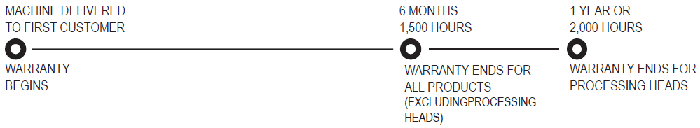
For extended warranties provided on certain components, see Appendix 1.

This warranty is effective from the date the said product is delivered to the first customer as long as the Warranty Registration and Delivery Acknowledgement has been completed and submitted to Pierce via the electronic document found at www.piercepacific.com and/or www.denharco.com within fifteen (15) working days after the delivery of the product to the first customer.
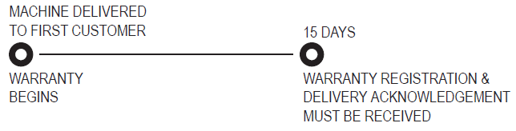
It is the customer’s responsibility to notify the dealer of any problem, and to make the product available to the dealer for repairs. This warranty covers repairs to, or in certain cases, replacement of defective parts, including labor, according to the rates set by Pierce. Pierce’s obligation and liability under this warranty agreement is expressly limited to repair or replacement of any non-conforming part, at Pierce’s option. The dealer is responsible for ensuring that a Pierce Pacific Mfg. and Pierce Denharco Warranty Claim Form (found at www.piercepacific.com and www.denharco.com) is completed and sent to the Pierce Warranty Administrator, no later than ninety (90) days after the date of the failure, in order to be eligible for credit.
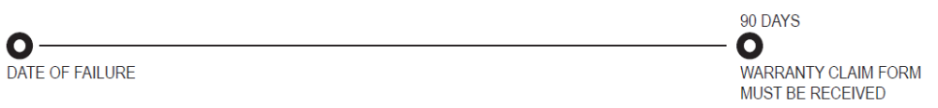
After receiving the completed Pierce Warranty Claim Form, defective parts must be held at dealer location for possible requested return. If requested for inspection, a Return Goods Authorization # will be issued by Pierce’s Warranty Administrator, and should be attached to returned parts. Returned parts without an RGA # will be refused. All shipments should be shipped ‘freight prepaid’. For further details, see section 4.2.0.

At the request of Pierce, if the dealer fails to return the requested defective part(s), as well as any related documentation, failure information or transaction documentation within fifteen (15) days of this request, Pierce reserves the right to automatically void the warranty claim in question.
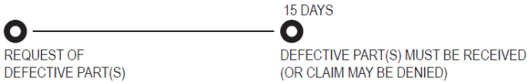
Any replaced or repaired part shall be under warranty for the remainder of the warranty period applicable to the product on which the part was installed. No extension of the product warranty period shall be granted to compensate for a period during which a product is out of commission for repairs or inspection, or because it was a demonstrator or returned rental product.

Pierce reserves the right to make changes and improvements to it’s products and parts with no obligation to it’s dealers and customers. In the case of any modification or improvement requested along with repairs or replacement parts, Pierce shall not be bound but may, at its discretion, apply these modifications or improvements at the customer’s expense, to products or parts already sold.

No warranty credit shall be granted or imposed with respect to;
- Products that have been operated in excess of the rated capacities, misuse, neglect or accident.
- Products that have been altered or repaired in an unauthorized manner. Or, using anything other than Pierce authorized parts will void this warranty.
- Products that have not been maintained according to manufacturer’s preventative maintenance program as outlined in the Parts Manual and Operations & Service Manuals provided with said product.

NOTE: PIERCE PACIFIC MFG. & PIERCE DENHARCO WARRANTY PERIOD BEGINS ON THE DATE EQUIPMENT OR PART IS DELIVERED TO THE FIRST CUSTOMER.

2.1.1 ADJUSTMENTS WITHIN THE WARRANTY PERIOD

REIMBURSEMENT OF PARTS
In accordance with the provisions and during the period of the applicable warranty, Pierce will issue a credit as reimbursement to the dealer. This policy is related to those parts which fail within the applicable warranty period caused by faulty material or workmanship. It will not apply to any such parts which fail outside of the applicable warranty. This practice does not apply to policy adjustments presented for consideration.

RETURN OF FAILED PARTS
Parts requested by Pierce shall be returned transportation charges prepaid by the dealer with prior return authorization from Pierce if the parts have failed within the warranty period. However, a Warranty Claim Form must be submitted first, and in accordance with the Warranty Claims Procedure (section 4.1.0) as outlined. Pierce will determine whether parts will be replaced, repaired or credit issued.

RETURN OF DEFECTIVE NEW PARTS
Pierce service parts which deviate from specifications may be returned, transportation charges prepaid, for credit with prior authorization from Pierce in accordance with the Warranty Claims Procedure as outlined. However, claims will be refused on new material returned to Pierce in an unsalable condition from causes other than the defect noted. Pierce will hold these unsaleable parts for thirty (30) days after notifying the sender. If thirty (30) days have elapsed and no reply has been received, Pierce will assume that the material can be discarded.
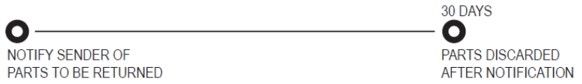
Pierce will reimburse the dealer for prepaid transportation charges via the least expensive common carrier, only for new defective parts when they are approved for credit. The original freight receipt must be attached to the claim form.

SPECIAL FABRICATIONS: RETURNS
The original customer or dealer will not be entitled to return material which has been purchased or fabricated for a special order or product.

MATERIAL SHIPPED IN ERROR
If the original purchaser receives material shipped in error by Pierce, this material may be returned to Pierce with prior authorization from Pierce Warranty Administrator. However, this material must be returned within thirty (30) days after receipt thereof, and must be unused and in good salable condition.

The original customer or dealer should always contact Pierce for shipping/billing arrangements of returned material. Also, include a brief explanatory note regarding return of the shipment.

2.1.2 EXTENDED WARRANTIES

Available on some products at additional cost. Such warranty agreements must be made at time of original purchase, and must be submitted in writing by an authorized Pierce representative.

- See Appendix 1.
- Applicable on new Pierce Pacific Mfg. & Pierce Denharco product sold after January 1, 2007.

2.1.3 EXCLUSIONS

WEAR ITEMS & CONSUMABLES
This warranty does not cover expendable parts, maintenance, wear or impact items on Pierce products, including (but not limited to) lubrication grease, oils, filters, shims, paint, shop supplies, tools, bulbs, fuses, cutting tools, saw bars, saw chains, hydraulic connectors, gaskets, O-rings and seals, gas and hydraulic accumulators, steel cables, delimber rollers and bearings, frequently flexing electrical cables (i.e. delimber and/or processing head boom cables) in addition to any other item that may show evidence of negligent use, overloading, abuse, accident, improper maintenance or storage, improper use, or unauthorized alterations.

Flexible and rigid hydraulic hoses have a 90 day warranty period from when the machine was delivered to the first customer.

Applicable warranties shall be assigned to the first customer only.

The following situations do not qualify for a refund pursuant to the warranty.

ADDITIONAL EXCLUSIONS:
- product damaged during shipping or storage;
- corrosion affected components;
- transportation of product or parts for inspection and/or repair purposes;
- costs incurred by overtime work;
- lost production costs;
- troubleshooting and diagnosis;
- cost of use of a similar product during repairs under warranty;
- cost of transportation and communications during repairs under warranty;
- damage resulting from a defective hydraulic system, including hydraulic lines;
- any components (i.e. motors, valves or computers) opened without the consent of the manufacturer;
- any components (i.e. motors, valves or computers) inspected and found to have corrosion due to improper storage;
- parts from which the identification number or serial number has been removed;

This warranty shall be null and void if non-Pierce components, repairs or alterations have been made to a Pierce product by persons or firms not subject to the prior approval of Pierce. This will also be null and void if, in the opinion of Pierce, such repairs or alterations could have adverse effects on the performance or reliability of the product. Installation of a Pierce product on a carrier vehicle not specifically approved by Pierce shall void this warranty.

Modifications made to Pierce products without the authorization of Pierce and/or repairs made with non-Pierce approved parts shall void this warranty. This warranty shall also not apply to any breakage attributed to improper installation or improper use of parts or components; or to a lack of proper care and maintenance.

This warranty does not cover the performance of the vehicle on which a Pierce product is fitted, or any component of such vehicle.

This warranty does not cover damage caused to a Pierce product by improper installation or damage caused by the vehicle on which the Pierce product is fitted.

NOTE: The provisions of this warranty policy shall not apply to any part which is used for a purpose for which it is not designated, or which shall have been repaired or altered in any way so as, in the judgment of Pierce, to affect adversely its performance and reliability, nor which has been subject to improper maintenance, misuse, negligence, accident or improper installation.

TRAVEL TIME
Reasonable travel expenses shall be reimbursed - up to a maximum 6 hour round trip. Travel time shall be claimed at the same rate as labor. Hotel, meal and fuel costs will not be reimbursed.

NOTE: It is not Pierce’s responsibility or fault that a dealer location or representative may not be nearby.

MILEAGE
Mileage expenses or fuel costs shall not be reimbursed.

FREIGHT
All freight costs for replacement parts are dealer/customer responsibility. All return parts shipments to Pierce must ship freight prepaid.

MAJOR REPAIRS & SUBCONTRACTORS
Significant/major repairs to Pierce equipment require notification prior to work beginning. This request for authorization is meant to keep issues of warranty payment from being denied, and also offers us the opportunity to ask questions, offer repair advise or assistance. Contact Warranty Administrator for authorization.

Also, in the case a subcontractor is hired for repair, an estimated cost for work to be performed by subcontractors shall be approved by Pierce before work begins. And if requested, necessary photos and documentation shall be provided prior to executing any work. If not supplied, parts and services will not be covered under this warranty agreement.

2.2.0 REPLACEMENT PARTS WARRANTY

Pierce warrants its new parts sold over the counter against any breakage resulting from defects in workmanship or materials, if used and maintained under normal conditions, for a period of ninety (90) days from the date the dealer invoices the customer.
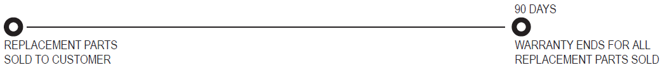

Within this period, it is the customer’s responsibility to notify the authorized dealer of any problem, and to make the product available to the dealer for repairs. The dealer is responsible for ensuring that a Pierce Warranty Claim Form is completed; for attaching two invoices issued to the customer as proof of the start and end of the ninety (90) day warranty period (the first showing the date the defective part was purchased, and the second showing the date the replacement part was purchased); and for sending them to Pierce’s Warranty Administrator, no later than ninety (90) days following the date of the repairs, in order to be eligible for credit.
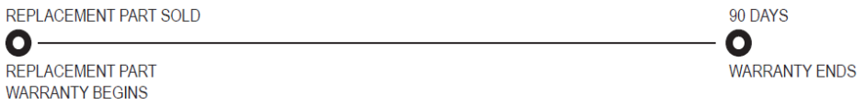
All defective parts shall be kept for eventual inspection. If, at the request of Pierce, the dealer fails to return the defective part(s) within fifteen (15) working days of this request, Pierce reserves the right to automatically void the warranty claim in question.
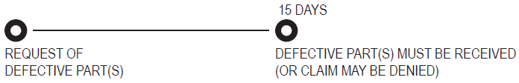
Any replaced or repaired part shall be under warranty for the remainder of the warranty period applicable to the product on which the part was installed. Pierce shall have no obligation or liability under this warranty unless an examination discloses, to its satisfaction, that a returned part is defective. The warranty does not cover labor, shipping or any other associated costs.

NOTE: Pierce make no warranty whatsoever in respect to proprietary components, parts, or trade accessories not manufactured by Pierce, but instead the applicable warranties, if any, of the respective manufacturers therefore shall be assigned to the first customer. Non-Pierce manufactured items carry manufacturers warranty only.

See Parts Sales Terms and Conditions for further details of parts transactions and dealer requirements.

THIS WARRANTY IS EXCLUSIVE AND IN LIEU OF ALL OTHER EXPRESS OR IMPLIED WARRANTIES, WHETHER WRITTEN OR VERBAL, INCLUDING BUT NOT LIMITED TO, IMPLIED WARRANTIES OF MERCHANTABILITY OR FITNESS FOR A PARTICULAR PURPOSE.
THIS WARRANTY IS TO BE GOVERNED BY AND INTERPRETED IN ACCORDANCE WITH THE EXISTING LAWS, TRADE PRACTICES AND USES OF BOTH CANADA AND THE UNITED STATES.

WHOLEGOOD AND REPLACEMENT PARTS DISCLAIMERS
No Pierce representative or distributor has the authority to modify, extend or change the clauses of this warranty.

The provisions of this warranty shall not apply to any part which is used for a purpose for which it is not designated, or which shall have been repaired or altered in any way so as, in the judgment of Pierce to affect adversely its performance and reliability, nor which has been subject to improper maintenance, misuse, negligence, accident or improper installation.

Pierce shall not be held liable for damages (i.e. lost production time), including accidental or incidental damages arising from its fault, negligence or other causes. The above-mentioned warranty shall constitute the sole right and recourse available to the customer.
3.0.0 WARRANTY VALIDATION

For warranty to be valid, the following documents are mandatory:
- Warranty Registration Certificate must be completed and submitted to Pierce no later than fifteen (15) working days of the date the product was delivered to the first customer.
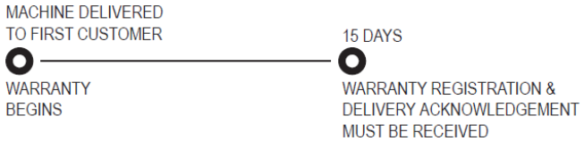
- Warranty Registration Certificate can be found at www.piercepacific.com and www.denharco.com.
- The product warranty is effective as of the start-up date entered on this document. Any warranty claim may be denied if it is received by Pierce’s Warranty Administrator before the Warranty Registration and Delivery Acknowledgement.
- Installation Inspection Report is required to be completed and returned to Pierce for all products not installed by Pierce. When installation is executed by the dealer, the Installation Inspection Report must be authorized at installation location by the Pierce representative.

3.1.0 SCALE OF DISTRIBUTOR REFUNDS

PARTS
All parts for which the Pierce Warranty Administrator has approved a warranty claim shall be refunded as follows:
- As charged by Pierce for the replacement part.
- Proof of purchase is necessary.
- Some parts may be recalled for inspection.
  - ALL PARTS MUST BE HELD FOR INSPECTION.

Only genuine Pierce parts can be claimed.

LABOR
Refunds will be made according to a repair time estimated by Pierce’s Warranty Administrator for certain repairs.
For these repairs, Pierce utilizes a predetermined, budgeted time estimate for warrantable repairs. Labor reimbursement will be credited in accordance to this table. Labor reimbursement is only for machines in their basic warranty time frame.

Contact the Warranty Administrator for appropriate labor rates.

Where the distributor must entrust all or part of the repair work to a subcontractor, a written estimate shall be prepared beforehand. Pierce’s Service Manager shall approve the estimate prior to any work being executed. The same refund policies shall apply for this work.

NOTE: Our intent is to cover dealer expenses only. Our warranty policy is not designed to provide a profit center for the dealer. For this reason, our warranty rate may not match the dealer rate reflected on a claim.

3.2.0 REVIEW OF DECISION

A distributor who wishes to appeal a claim settlement decision must communicate, in writing, the reasons for requesting a second examination of the warranty claim to the Pierce Warranty Administrator. A committee of experts will review each case for final decision.

3.3.0 WARRANTY POLICY: PRODUCTS IN STOCK

The dealer shall conduct periodic monthly inspections of product(s) in stock. All forms used for this purpose must be kept on file on the dealer’s premises so that copies may be supplied to Pierce upon request. The distributor shall be solely responsible for any breakage, loss or deterioration that may occur to products in inventory, and shall take the necessary steps to ensure that products are properly stored. If, during the storage period, a warranty claim is deemed necessary, it shall be accepted only in the case of a manufacturing defect, and not in the case of improper protection or storage.

3.4.0 WARRANTY POLICY: PRODUCTS ON DEMONSTRATION/RENTAL AGREEMENT

Demonstrations are sometimes required to promote sales. It is the dealer’s responsibility to ensure that any product used as a demonstrator is in perfect working order.
A product used as a demonstrator for fewer than two hundred (200) hours shall be considered as new for warranty validation purposes.
In the case of a product that has logged more than two hundred (200) hours of use as a demonstrator, the warranty period validation shall take into account the number of demonstration hours logged.

If requested by Pierce, a Demonstration Report should be sent to Pierce’s Warranty Administrator.

For rental products, our standard warranty policy applies. The first rental customer shall be considered the first customer, initiating the warranty period.

4.0.0 WARRANTY CLAIMS

4.1.0 WARRANTY CLAIMS PROCEDURES

The warranty claims procedure is designed to minimize the time and effort required of dealers to submit claims, as well as to provide the best possible settlement.
To ensure prompt settlement, the Warranty Claim Form must be completed and returned according to the schedule set forth in this document.
The only acceptable warranty claim form is that produced by Pierce. It is available at www.piercepacific.com and www.denharco.com, under the ‘Warranty’ header.

The procedure for completing and filing a claim is as follows:

- COMPLETE THE FORM (see appendix 4):
- ‘RESERVED SECTION’ is for factory use only and should be left blank.
- Write a detailed description of the defect and the repairs made, including the date the repair was executed. A copy of the dealer’s work order must accompany the warranty claim to provide better documentation relevant to the analysis of the problem.
- Enter parts costs needed for the repair and attach copy of dealer’s parts invoice (from Pierce) with claim.
- Enter labor hours that were needed to perform the repairs. (It is the dealer’s responsibility to ensure that Pierce’s Warranty Administrator is informed of the standard hourly rates in effect on the dealer’s premises.)
- The serial number of the Pierce product must be entered on the form, as well as the associated and applicable part numbers of the defective parts. The serial number of the replacement part (if applicable) must be entered in the ‘CLAIM MATERIAL’ section.
- In the case of repair work done as instructed by Pierce representative, enter the representative’s name and the date on which the advice was given on the claim form.

- SEND THE FORM:
- Each claim that includes replacement part(s) must be accompanied by a copy of the Pierce parts sales invoice, so as to justify the refund amount being claimed.
- When breakage is structure-related, photographs clearly showing the state of the product before and after the repair work (such that the damages, as well as the corrective action taken) must be included with the claim form. NOTE: To assure a proper structural repair, the dealer must request procedural, as well as financial authorization by sending a written estimate of the cost of the said repair work.
- All warranty claims must be received by the Pierce Warranty Administrator no later than ninety (90) days after the date of the failure.
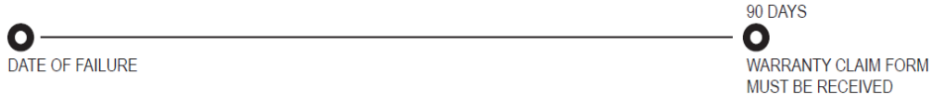
- No warranty claim can be processed unless we have first received the Product Registration and Delivery Acknowledgement. In the event that a Product Registration and Delivery Acknowledgement is not on file, then the original dealer ship-date will become the effective in-service date.
- Submit the Warranty Claim Form to the Pierce’s Warranty Administrator to expedite processing. See appendix 5 for contact information.

NOTE: The Pierce Pacific Mfg. & Pierce Denharco Warranty Claim Form is available in electronic format at www.piercepacific.com and www.denharco.com, under the ‘WARRANTY’ header.

RETURN OF PARTS, AS REQUESTED
Failed or defective parts requested for return by Pierce shall be returned, transportation charges prepaid by the dealer with prior return authorization from Pierce if the parts have failed within the warranty period. However, a Warranty Claim Form must be submitted first, and in accordance with the Warranty Claims Procedure (section 4.1.0) as outlined. Pierce will determine whether parts will be replaced, repaired or credit issued. Collect shipments will be refused.

ISSUING A CREDIT ON THE CLAIM
Warranty credit for parts shall be based on the net price in effect on the date the failure occurred, or on the actual net price shown on the applicable Pierce invoice on which the replacement parts were obtained.

If material is not approved for credit, then the dealer will be advised as to the reason for withholding credit and disposition of the returned parts will be requested.

Material which no credit is allowed will be held for a maximum of thirty (30) days by Pierce while awaiting instructions regarding its disposition, after which it will be discarded.
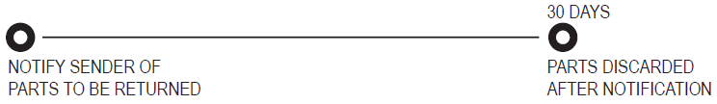

DISCARDING OF MATERIAL IN DEALER/CUSTOMER’S FACILITY
Authorization by Pierce’s Warranty Administrator must be obtained prior to the discarding of parts at the customer or dealer location.

4.2.0 RETURNING CLAIMED/DEFECTIVE PARTS

It may be necessary to return claimed/defective parts to Pierce. In such cases, a Return Goods Authorization (RGA) # issued by Pierce is required for parts needing further inspection. Parts must be returned freight prepaid, to Pierce’s Warranty Administrator. All parts shipped should be shipped to Pierce’s Portland, Oregon facility. See appendix 5 for shipping information.
To expedite claims processing, returned parts must be cleaned and accompanied by a copy of the Return of Goods Authorization number (RGA #), clearly labeled on the returned shipment.
In cases where the dealer does not return a claimed/defective part required by Pierce, within fifteen (15) working days of the date indicated by the Return Goods Authorization number (RGA #), then the associated claim may be denied.
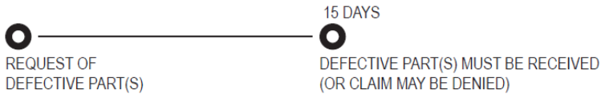
NOTE: Contact Pierce’s Warranty Administrator for RGA #.

IMPORTANT: Do not ship returned parts without an RGA #.

4.3.0 FIELD CAMPAIGN PROCEDURES

NOTIFICATION OF CAMPAIGN
- Notification of campaign programs will be provided to the affected dealer through a Service Bulletin from Pierce’s Service Department which will contain complete instructions on the unit, serial numbers and service parts, by part number, to be campaigned.
- A service bulletin will be issued to cover each authorized campaign. The identification number of the bulletin is important in that it is essential that this identification be used not only on each claim presented, but also on any related correspondence.

DESCRIPTION OF CHANGE
Each bulletin will contain a brief description of the product problem encountered in which the campaign has been instituted to correct.

ORDERING CAMPAIGN MATERIAL
Upon receipt of the bulletin announcing a campaign, the organization responsible for executing the campaign should determine the number of units within its service responsibilities thereby projecting campaign parts requirements. These should be purchased immediately by placing an order with the Pierce’s Parts Sales Department.

A complete listing of appropriate parts to be removed, as well as parts required, will be contained in the bulletin.

REPLACEMENT PROCEDURE
A complete replacement procedure, by part number, is contained in the bulletin (i.e.,disassembly and assembly procedures, special caution notes, etc.)

SPECIAL INSTRUCTIONS
The bulletin will describe clearly any/all instructions necessary to complete the campaign (such as stamping an identification letter on the product or nameplate).

DISPOSITION OF REPLACED PARTS
Complete disposition instructions of all parts removed in conducting the campaign is provided in the bulletin.

REIMBURSEMENT VIA APPLICATION FOR ADJUSTMENT
- Upon completion of the campaign, a Warranty Claim Form should be submitted requesting credit. Reasonable or pre-arranged labor expenses will be agreed to by Pierce.
- The service bulletin number and the identifying Pierce serial and model numbers of the product must be entered on this Warranty Claim Form.
- Only the material specified in the bulletin as being necessary to conduct the campaign will be accepted on the claim submitted.
- The claim shall be filed in accordance with procedures outlined in section 4.1.0.
- When parts are authorized in the bulletin to be returned to Pierce, credit consideration will not be given to any claim until the parts are received by Pierce. An RGA # is required for all accompanied returned parts.

IMPORTANT
NOTE: Pierce will correct the conditions outlined in the campaign bulletin. However, any unreasonable delay on the part of the organization conducting the campaign, or problems encountered in product availability for such repair could result in additional damage or abnormal wear to adjacent or related parts. Pierce cannot accept responsibility for any consequential damage or abnormal wear to other components which can reasonably be attributed to delay in conducting the required corrections.

SERVICE ASSISTANCE & REPAIRS
- While field service assistance is not always available from Pierce, if the selling dealer does require assistance, it may be available by request from Pierce.
- In the event that factory assistance is required, the service and repair work will be scheduled on an ‘as available’ basis and is subject to the following terms:
- Service work will be invoiced at the prevailing labor rates for regular and overtime work, and must be preceded by a purchase order from the dealer.
- Service work which may be of a possible warranty nature will require a purchase order from the dealer prior to the work being done. The service work will be considered as billable service work until such time as an informed determination can be made. The customer is responsible for all or any part of the work not subsequently determined to be of a warrantable nature.
- Warranty and/or possible warranty service work will be provided on a regular time basis only. If overtime work is required because of dealer/customer requirements, a purchase order will be required in advance, to cover the premium portion of the expected overtime.
- All assistance requests should be submitted on the warranty form identified as “POLICY REQUEST”. The Warranty Administrator will forward his recommendations to the committee for final decision.

5.0.0 SERVICE PUBLICATIONS

GENERAL POLICY, NEW WHOLEGOOD PRODUCTS
Service publications are prepared and available as an aid to proper and efficient operation, maintenance and repair of Pierce wholegood products, including stroke delimbers, processing heads, felling attachments, crane carriers, crawler undercarriages, hydraulic booms, buckets and grapples. A no-charge distribution policy provides two (2) copies of the Parts, Service & Operations Manuals. One set is assigned to the first customer of each new Pierce product, and the second set is assigned to the selling dealer. Additional requirements can be obtained by purchasing additional copies through our Parts Sales Department.

SERVICE LITERATURE PROCUREMENT/CHARGES
- Upon shipment of a new Pierce wholegood product, Parts, Service & Operations Manuals pertaining to the model shipped is made available to the first customer. This material is inclusive in the wholegood purchase from Pierce. It is the dealer’s responsibility to deliver (1) set of manuals to the first customer.
- Dealer requests for service literature must be made using a written purchase order which supplies the Pierce model number and serial number of the said product and the name of the person in the dealer’s organization to which the material is to be sent.
- Any literature which Pierce has available can be ordered through:
PIERCE PACIFIC MANUFACTURING, INC.
PIERCE DENHARCO, INC.
PARTS SALES DEPARTMENT
4424 N.E. 158th Ave
Portland OR 97230
PO Box 30509
Portland, OR 97294
Phone: 503.808.9110
Toll Free: 800.760.3270

- Charges are billed for other service information, as well as additional copies of Parts, Service & Operations Manuals.

SERVICE LITERATURE, USED MACHINES
Parts, Service and Operations Manuals for non-current Pierce & Pierce Denharco products are available subject to availability of service information. In some cases delay may be encountered in obtaining materials for non-current machines or components. Parts, Service and Operations Manuals for non-current products can be ordered from the Pierce Parts Sales Department. A charge will be made for non-current manuals which may vary in some instances depending on available materials.

6.0.0 DEALER’S RESPONSIBILITIES

As a Pierce Pacific Mfg. & Pierce Denharco dealer, you are responsible for:
- Conducting a visual inspection whenever a Pierce product is unloaded on your premises.
- Checking each product for damage that may have occurred during shipping. Pierce cannot be held liable for damages that occurred during shipping. Any associated claims must be filed with the freight carrier.
- Checking all packaged parts or components, within twenty-four (24) hours of receipt, against the packing slip to see whether shipping errors have occurred. If there are missing parts, please notify Pierce.
- Conducting a final installation inspection at time of completion using the Pierce Installation Inspection Form. Contact Pierce for Installation Inspection Form for specific product.
- The dealer is solely responsible for any breakage, loss or deterioration that may occur to products in inventory and must take the necessary steps to ensure that products are properly stored. If, during the storage period, a warranty claim is deemed necessary, it shall be accepted only in the case of a manufacturing defect, and not in the case of improper protection or storage.
- Conducting an inspection at the time the equipment is started up on the work site, using the Pierce Installation Inspection Form, and completing the report specific to the product.
- Forward all Service Bulletins, and Product Updates as provided by Pierce to the customer within 7 days of receipt of such information.
- Completing the Warranty Registration and Delivery Acknowledgement, assuring accurate contact information regarding your customer. Any relevant information that is missing may delay implementation of warranty. Returning the Warranty Registration and Delivery Acknowledgement to the Pierce Warranty Administrator - this is essential for the validation of our warranty policy. No claim can be accepted before this document is completed and signed by the persons concerned.
- Process all claims in accordance with the Pierce Warranty Manual.
- As the customer’s primary source of information, you are responsible for informing your customers about the necessity of following a preventive maintenance program, best operating practices, and the safety rules to be followed when using Pierce products.
- Service or Product Support Representatives can help you solve technical problems over the telephone. In cases where a Pierce Service Representative may be required to the site where the product is located, the dealer is responsible for dispatching his own technical personnel to the site at the same time, as well as issuing an order for Pierce’s labor.
- Provide customer with all necessary manuals & relevant publications for the safe operation and timely maintenance of the unit.

NOTE: Pictures do “say a thousand words”. Claims are likely to be processed more efficiently when pictures of failures and repairs are submitted with a claim. Please take photos anytime repairs are made for which parts will not be submitted for inspection.

6.1.0 CUSTOMER RESPONSIBILITIES

As a Pierce Pacific Mfg. & Pierce Denharco customer, you are responsible for:

- Preventative Maintenance: Regular routine maintenance must be performed according to the Pierce maintenance procedures outlined in the Pierce Parts, Service & Operations Manuals.
- Repair Procedures: Any repair procedure must follow accepted industry practice and meet factory approval. Parts necessary for maintenance and repair must be genuine Pierce parts.
- Records Submission: Certain Pierce products may require operating and maintenance records to be submitted. This information must be submitted to Pierce as requested.
- Compliance: Failure to comply with any of the requirements set forth in this Warranty Manual could result in the amendment or cancellation of this warranty. In this event, Pierce will not refund the unused portions of any warranty.

APPENDIX 1: EXTENDED WARRANTY POLICY

DELIMBER BOOMS

As an extension to standard product warranty, Pierce warrants the boom(s) of its new delimbers against defects in workmanship or materials for a period of two (2) years or 3,000 hours (first occurring) on a pro-rata basis. Refunding on a pro-rata basis is calculated according to the following table.

ORIGINAL BOOMS ON DELIMBERS: PURCHASED NEW
DURATION HOURS REFUND COVERAGE
0-1 Year, or 0–2,000 100% of purchase price Parts & Labor
1-2 Years, or 2,001–3,000 50% of purchase price Parts Only

Pierce also warrants delimber booms purchased as replacements for a period of one (1) year or 2,000 hours (first occurring) on a pro-rata basis. Only Pierce booms purchased as replacements for a Pierce Pacific Mfg. and/or Pierce Denharco delimber are covered under this policy. Refunding on a pro-rata basis is calculated according to the following table.

REPLACEMENT BOOMS ON DELIMBERS: PURCHASED NEW
DURATION HOURS REFUND COVERAGE
0-90 Days 100% of purchase price Parts Only
90 Days-1 Year, or up to 2,000 hours 50% of purchase price Parts Only

NOTE: Boom assemblies are subject to faster wear when installed on existing machines. For this reason, the warranty coverage varies between booms on new machines vs. used machines.

Any replaced or repaired part shall be under warranty for the remainder of the warranty period applicable to the product on which the part was installed, or for a specific period allotted to that particular part. This warranty does not cover defects resulting from use other than delimbing; booms damaged or bent resulting from use other than delimbing; or booms that have been modified, altered or repaired. This warranty does not cover any collateral damages to other components (i.e. rollers) affected by a damaged/bent boom.

This extended warranty does not cover any maintenance procedures or freight incurred while executing this policy.

NOTE:Freight is customer’s responsibility.

NOTE: Pierce reserves the right to terminate this extended warranty at any time, on thirty (30) business days’ notice.

ORIGINAL DELIMBER DRIVE CHAIN
DURATION HOURS REFUND COVERAGE
0-1 Year, or 0–2,000 100% of purchase price Parts & Labor
1-2 Years, or 2,001–3,000 50% of purchase price Parts Only

Warranty covers reasonable parts and labor required to repair or replace. All warranty is subject to standard Pierce guidelines. Complete chain replacement must be authorized by Pierce before work begins. Drive chain segments are available in different lengths, and should be used prior to replacing complete chain assembly.

Drive Chains replaced under warranty are warranted for the remainder of the warranty period applicable to the product on which the part was installed.

Replacement part drive chains carry standard Pierce parts sales warranty (90 days).

This extended warranty does not cover any maintenance procedures or freight incurred while executing this policy.

NOTE:Freight is customer’s responsibility.

NOTE: Pierce reserves the right to terminate this extended warranty at any time, on thirty (30) business days’ notice.

ORIGINAL DELIMBER DRIVE MOTORS
DURATION HOURS REFUND COVERAGE
0-1 Year, or 0–2,000 100% of purchase price Parts & Labor
1-2 Years, or 2,001–3,000 50% of purchase price Parts Only

Motors replaced under warranty are warranted for the remainder of the warranty period applicable to the product on which the part was installed.

Replacement parts drive motors carry standard Pierce parts sales warranty (90 days).

All warranty is based on approved report from Product Manufacturer. Parts will be billed to customer until a determination is made.

This extended warranty does not cover any maintenance procedures or freight incurred while executing this policy.

NOTE:Freight is customer’s responsibility.

NOTE: Pierce reserves the right to terminate this extended warranty at any time, on thirty (30) business days’ notice.

APPENDIX 2: COMPUTERS

NEW MACHINE COMPUTERS
Included in the standard product warranty, Pierce warrants the optional measuring system computers available with its various products against defects in workmanship or materials for the duration of that product’s warranty from the date of delivery. Any replaced or repaired part shall be under warranty for the remainder of the warranty period applicable to the product on which the part was installed, or for a specific period allotted to that particular part.

This warranty concerns the following current production computers: Dasa on Pierce Denharco processing attachments, as well as Intellitec on Pierce attachments.

In cases of defects to one of the computer models listed above, Pierce will replace the unit either with a ‘new’ or ‘reconditioned’ unit, and will be warranted for the remainder of the warranty period.

This warranty does not cover computers damaged by peripheral devices connected to the computer (i.e. monitor, cables, etc.), external impacts, and/or showing external signs of abuse or impact, accidental or otherwise; or software upgrades.

REPLACEMENT COMPUTER SALES
Replacement computers will be sold at a flat transaction rate predetermined by Pierce. In addition, a core charge will be billed to the dealer/customer. If failed computer is returned to Pierce with description of fault(s) and/or error(s), then the core charge will be credited in-full upon receipt of failed computer. If core is credited, then customer’s original computer will not be returned to original customer. Replacement computers will be ‘reconditioned’ and warranted for 6 months from time of invoice.

This warranty concerns the following computers: Control Plus, ProCommander and Dasa on Pierce Denharco processing attachments, as well as Intellitec, MK2 Measuring Systems on Pierce attachments.

This warranty does not cover any freight incurred in executing this policy.

Pierce reserves the right to terminate this warranty at any time, on thirty (30) business days’ notice.

APPENDIX 3: TERMS AND CONDITIONS
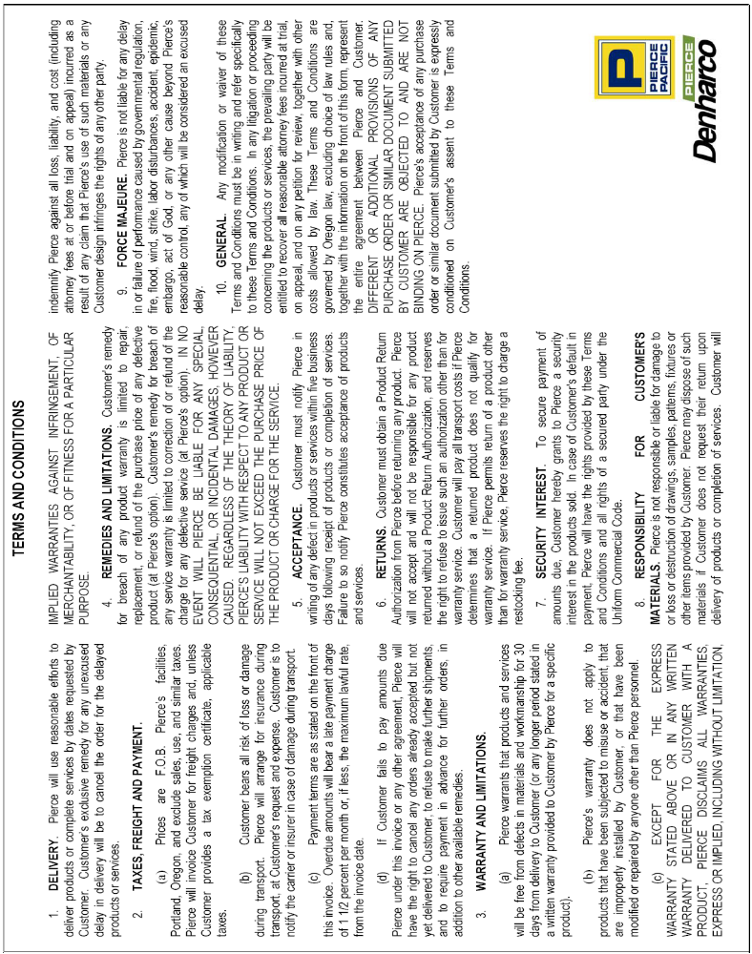

APPENDIX 4: IMPORTANT DOCUMENTS

WARRANTY REGISTRATION AND DELIVERY ACKNOWLEDGEMENT
(found at www.piercepacific.com & www.denharco.com) 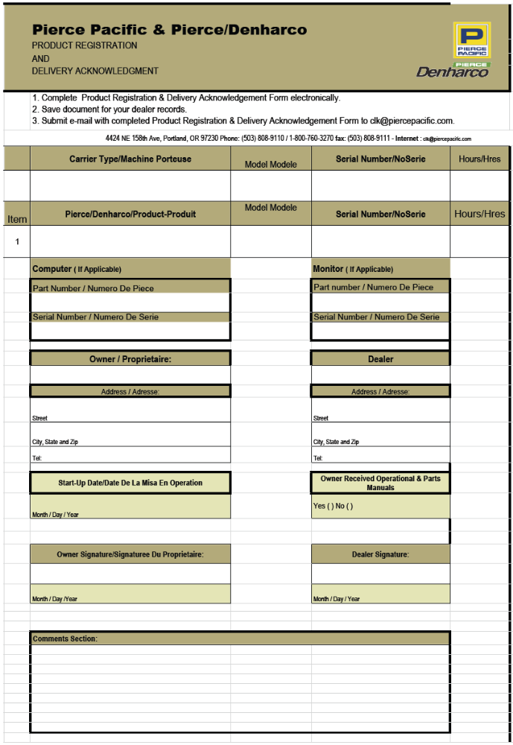
WARRANTY CLAIM FORM
(found at www.piercepacific.com & www.denharco.com)
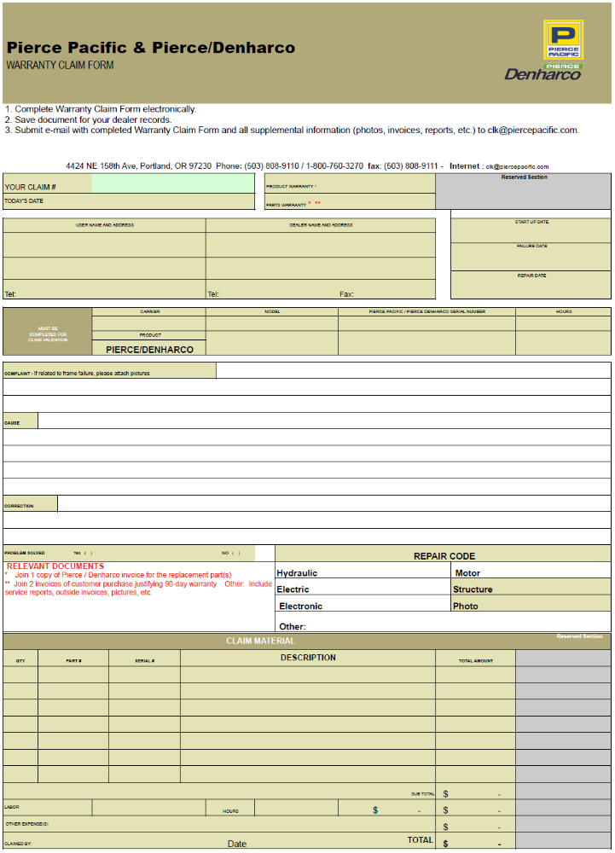
APPENDIX 5: CONTACT US

UNITED STATES:
PIERCE PACIFIC MFG. & PIERCE DENHARCO
Mailing Address:
P O Box 30509
Portland, Oregon 97294
U.S.A.
Physical/Shipping Address:
4424 NE 158th Ave.
Portland, Oregon 97230
U.S.A.
Website: www.piercepacific.com, www.denharco.com
E-Mail: info@piercepacific.com, info@denharco.com

Phone: 503.808.9110
Toll Free: 800.760.3270
Fax: 503.808.9370

Parts Sales Phone: 503.808.9390
Parts Sales Toll Free: 800.824.3637
Parts Sales Fax: 503.808.9370

DISTRIBUTION WAREHOUSE: Baton Rouge, Louisiana

CANADA:
PIERCE DENHARCO
Website: www.piercepacific.com, www.denharco.com
E-Mail: info@piercepacific.com, info@denharco.com

Parts Sales Phone: 800.363.1587 X221

DISTRIBUTION WAREHOUSE: Edmonton, Alberta

IMPORTANT
All parts authorized for return, should be sent to the Portland, Oregon location with attached RGA #. Attn. Warranty Administrator.

